HD 204313

HD 204313 is a 1.02 M☉, G5 V star1. The CH survey reported a GP (HD 204313b) signal with a period of 2132 days, a minimum mass of 4.65 MJup and an eccentricity of 0.11 as well as a Hot Jupiter (HD 204313c) signal with a period of 34.88 days, a minimum mass of 0.053 MJup and an eccentricity of 0.13. Based on 36 RV 2.7m Hobby-Eberly Telescope (HET) measurements obtained between 2003 and 2011 and 97 RV CORALIE measurements obtained between 2000 and 2008, a study performed in 2012 (hereafter R12)2 reported properties for HD 204313b close to those of the CH survey and a new GP (HD 204313d) with a period of 2831.6 ± 150 days, a minimum mass of 1.68 ± 0.3 MJup and an eccentricity of 0.28 ± 0.09. The latter was not confirmed by a subsequent analysis that included additional CORALIE and HARPS data1.

In the present study, in addition to the R12’s dataset, 19 additional CORALIE RV measurements obtained between 2008 and 2013 and 113 RV HARPS measurements obtained between 2006 and 2017 were considered. DPASS and MCMC (1000 walkers and 400000 iterations) were used to fit the data. To converge more easily, the priors on the semi-major axis and the minimum mass of HD 204313c were chosen close to the values found by the CH survey. The properties of planets b and c are close to those reported in the CH survey. Including a third planet does not significantly improve the rms, but a peak at about 3000 days with a FAP greater than 1% is present in the periodogram of the residuals. The fits are shown in Fig 1, and the corner plot in Fig 2, and the results summarized in Table 1.

Note that, recently, combining RV and Hipparcos/Gaia absolute astrometry data, considering a three-planets system, a study performed in 20223 reported orbital parameters close to those of the CH survey for HD 204313b and were able to estimate the orbital inclination, and thus the true mass, of HD 204313 c and d. They found, for HD 204313c, a period of days, an eccentricity of 0.100 ± 0.003, an inclination of °, and a mass of MJup and, for HD 204313d, a period of days, an eccentricity of 0.25 ± 0.07, an inclination of °, and a mass of MJup.

Conclusion: The properties found in the CH survey for planets b and c are confirmed.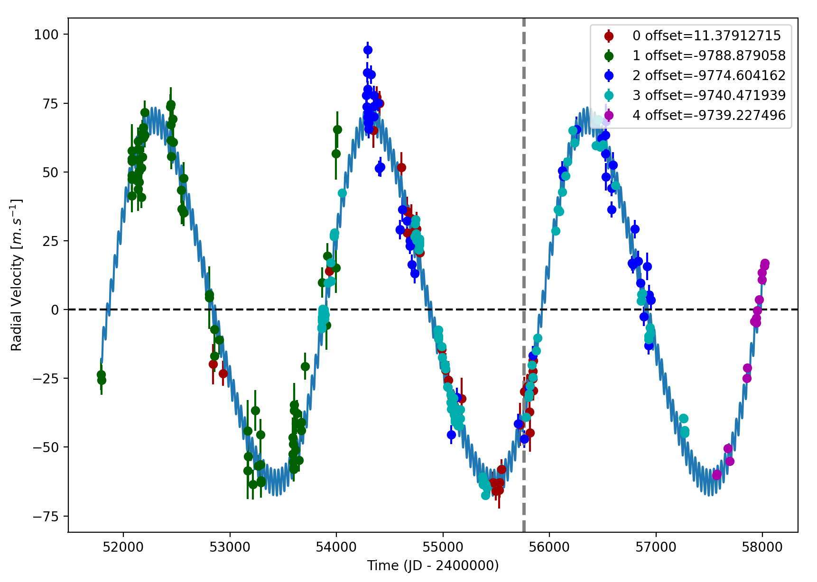

Figure 1: Left: fit of the HD 204313 RV with DPASS. Red - HET, green - C98, blue - C07, cyan - H03, purple - H15. The blue curve shows the best fit. Right: fit of the HD 204313 RV using MCMC. The black curve shows the best fit. The colorbar corresponds to the log-likelihood of the fits. The gray dotted line indicates the end of the CH survey.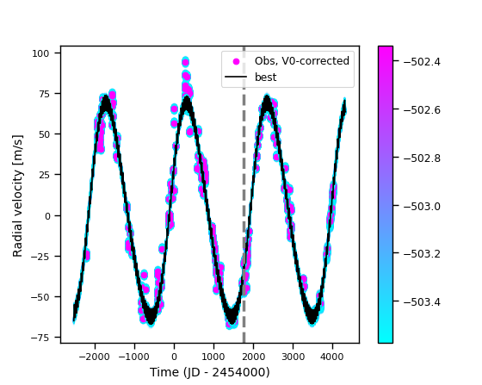

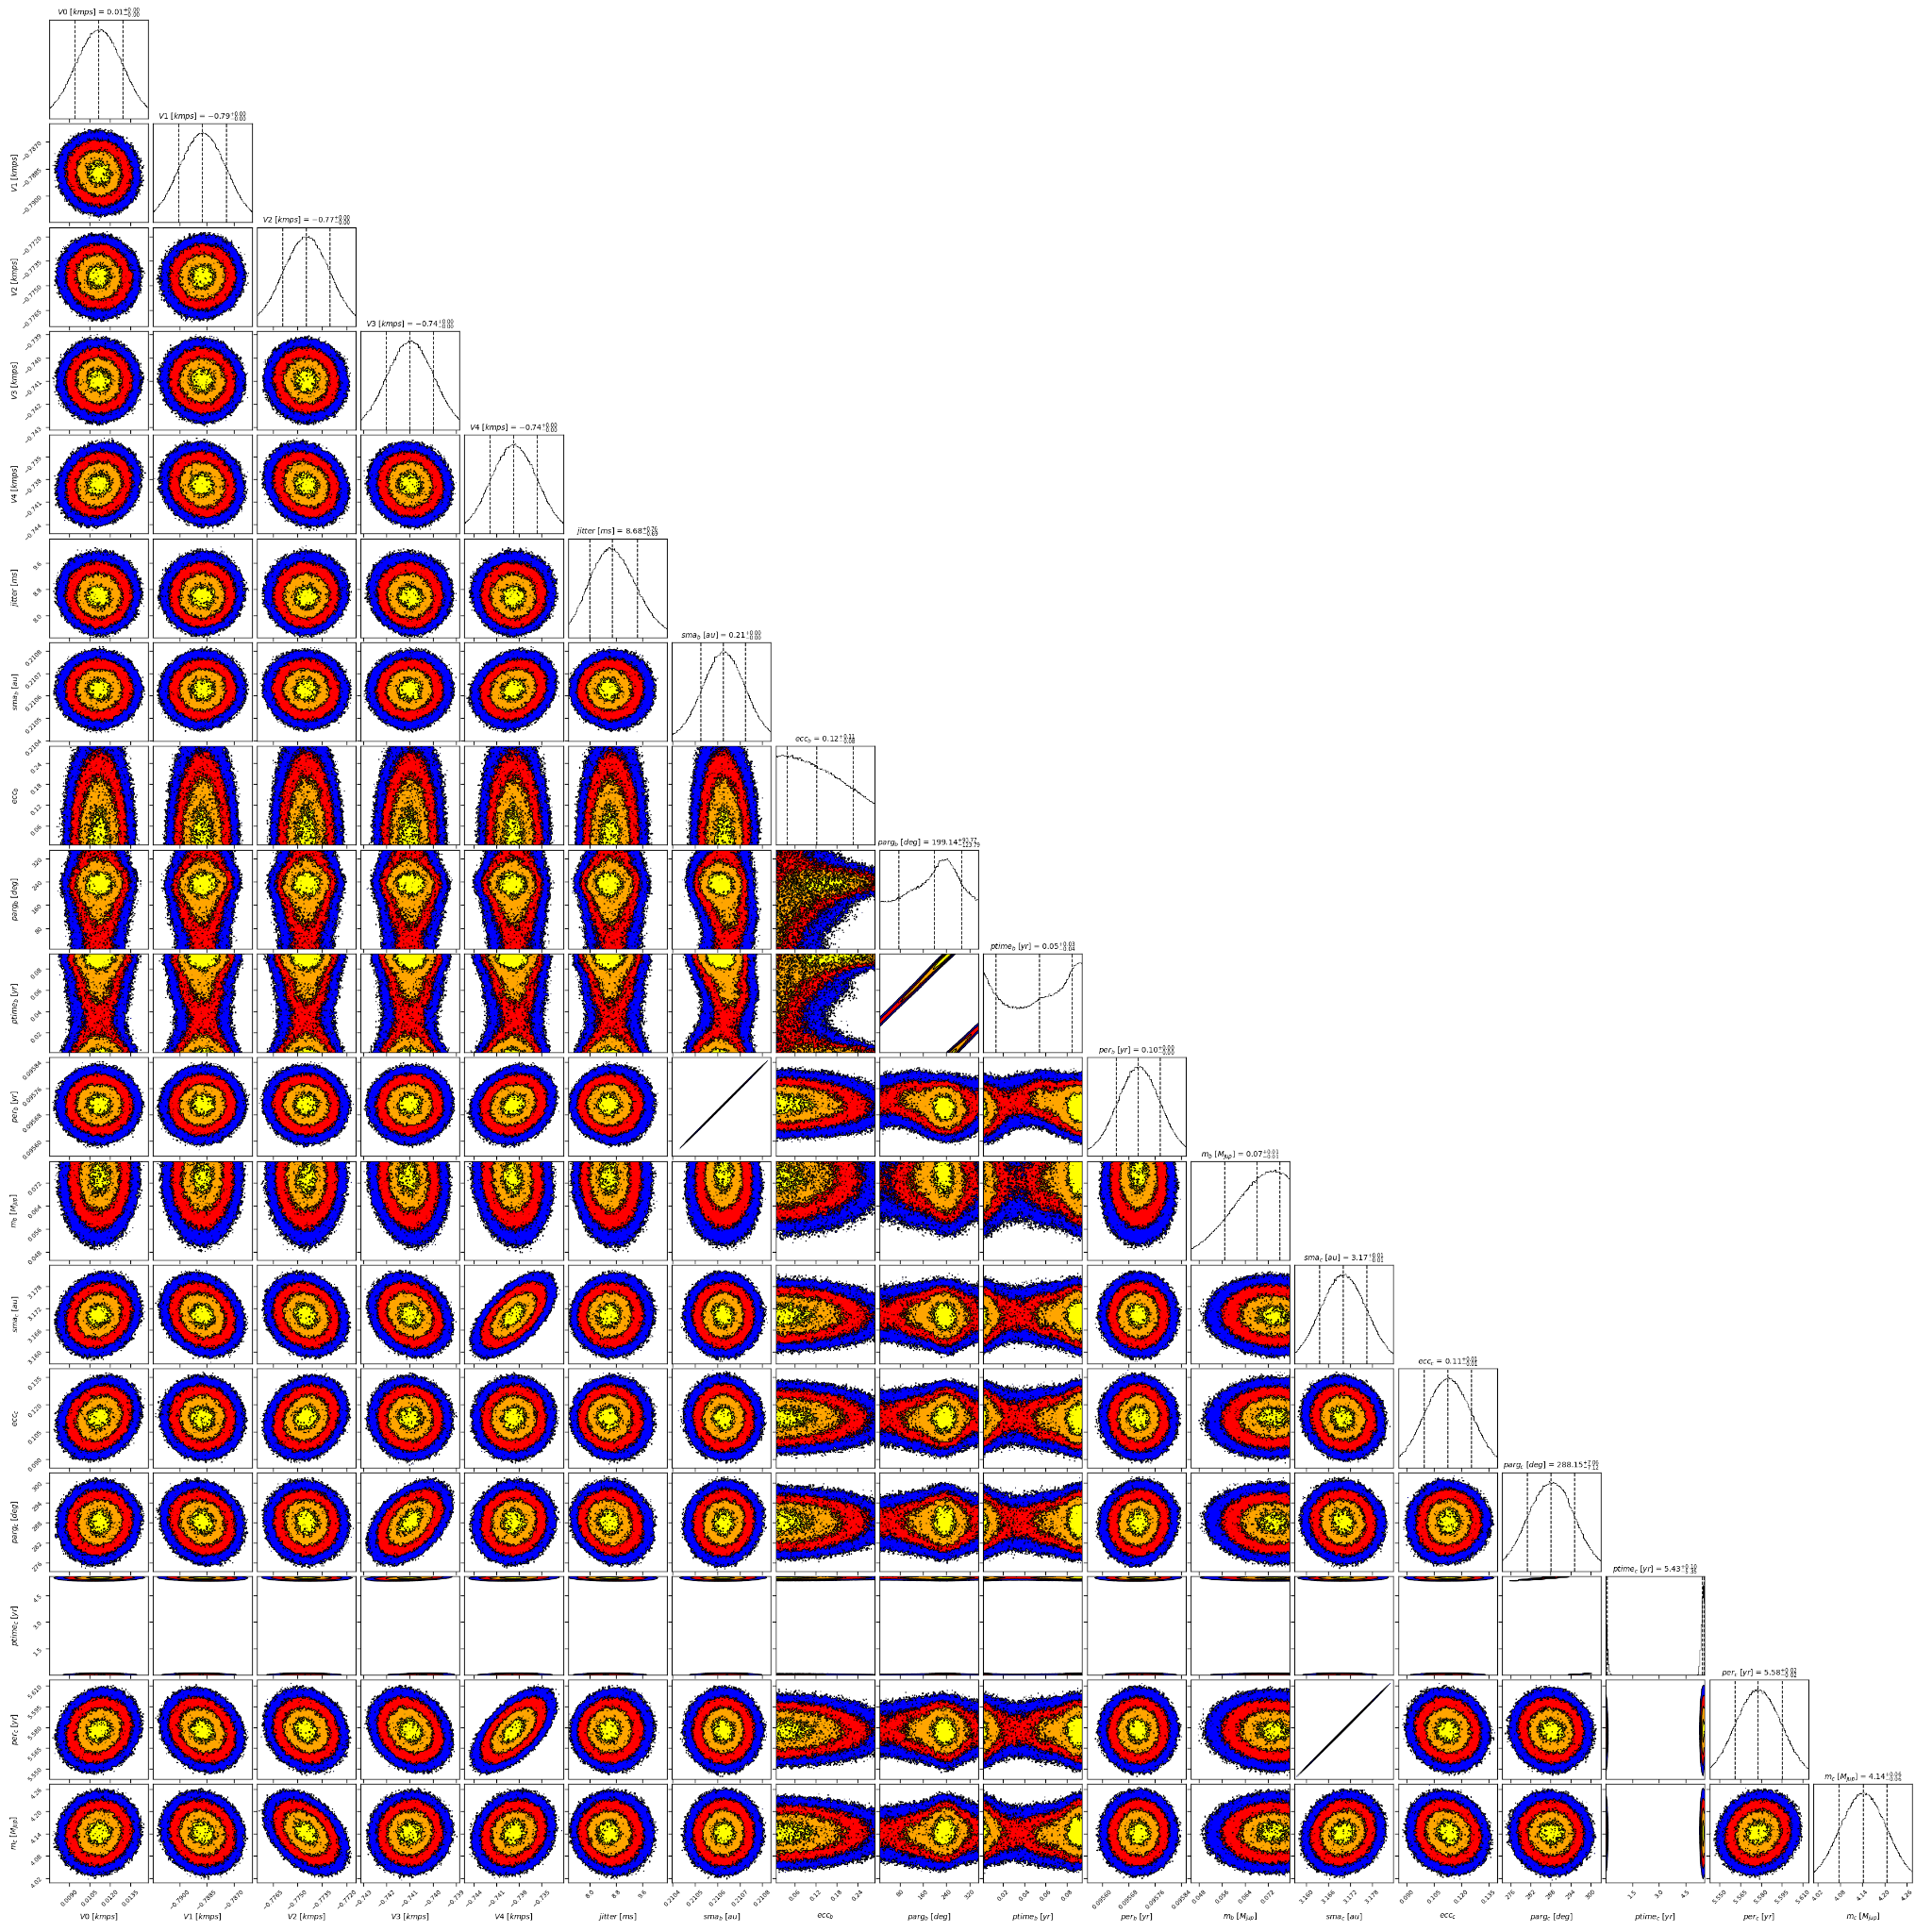

Figure 2: Corner plot of posteriors for the two-planets model MCMC fit of HD 204313 RV data.

| Parameter | Priors | | Posteriors | | CH survey |
| --- | --- | --- | --- | --- | --- |
|  | DPASS | MCMC | DPASS | MCMC |  |
| *a* (au) | b: [0,1]  c: [0,80] | b: [2,10]  c: [0.01,1] | b = 3.2  c = 0.21 | b = 3.17 ± 0.01  c = 0.210 ± 0.001 | b = 3.3  c = 0.2 |
| Msin(i) (MJup) | b: [0,1]  c: [0:100] | b: [0.1,5]  c: [0.01,1] | b = 4.1  c = 0.076 | b =  c = 0.07 ± 0.01 | b = 4.65  c = 0.053 |
| Eccentricity | b: [0,0.5]  c: [0,0.95] | b: [0,0.9]  c: [0,0.5] | b = 0.11  c = 0.2 | b =  c < 0.23 | b = 0.11  c = 0.13 |
| Instrumentals offsets (km/s) | [-100,100] | 2.7m: [-1,1]  C98: [-10,-8]  C07: [-10,-8]  H03: [-10,-8]  H15: [-10,-8] | 2.7m: 0.011  C98: -9.789  C07: -9.775  H03: -9.741  H15: -9.739 | 2.7m: 0.011 ± 0.002  C98: -9.789 ± 0.001  C07: -9.775+0.002-0.001  H03: -9.741 ± 0.001  H15: -9.739 ± 0.003 |  |
| Stellar jitter (m/s) | [0,40] | [0,20] | 8 | 8.7± 0.7 |  |
| Argument of periastron (°) | b: [0,360]  c: [0,360] | b: [0,360]  c: [0,360] | b = 298  c = 248 | b = 75 – 293  c = 288 ± 0.07 |  |
| Phase | b: [0,1]  c: [0,1] | b: [0,1]  c: [0,1] | b = 0.97  c = 0.54 | b = 0.14 – 0.89  c = 0.97 – 0.01 |  |

Table 1: HD 204313. Summary of priors and posteriors obtained with DPASS and MCMC, compared to the properties reported by the CH Survey.

References

1. Diaz, R. et al. The HARPS search for southern extra-solar planets. XXXVIII. Bayesian re-analysis of three systems. New super-Earths, unconfirmed signals, and magnetic cycles. *Astron. Astrophys.* 585, A134 (2016).
2. Robertson, P. et al. A Second Giant Planet in 3:2 Mean-Motion Resonance in the HD 204313 System. Astrophys. J. 754, 50–59 (2012).
3. Feng, F. et al. 3D Selection of 167 Substellar Companions to Nearby Stars. *Astrophys. J. Supp. Ser.* 262, 21 (2022).